* What is RDS database ?
* A relational database is is a datastructure that allow you to link information from different ‘tables’ or different types of data bucket.
* Table are related to each other.
* All field must be filled.
* Best suited for OLTP ( online transaction processing)
* RdS can’t scale out horizontally.
* Virtually all relational database use sql.
* Relational DB are usually used in enterprises application / scenario exception in my sql included php & java based web application that required a database storage backed .

I.e. Joomla

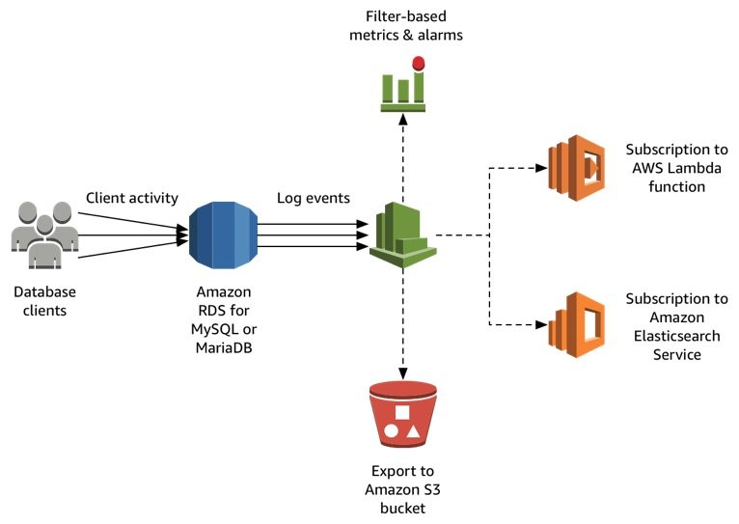

* .ms sql
* My sql
* Oracle
* Aws aurora
* Postgre sql
* Maria DB

1. **Create RDS my sql database.**

Aws management console **>**  service **>** RDS

1.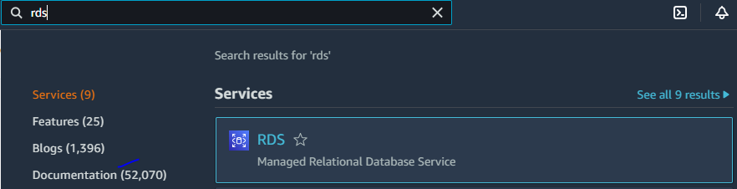

2.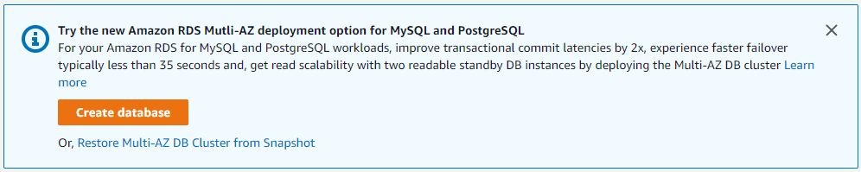

3. 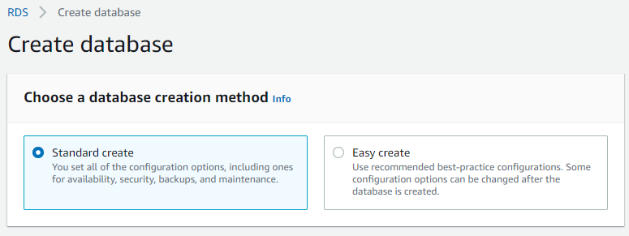

4. 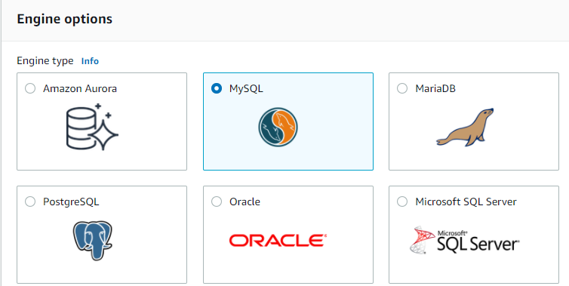

5. 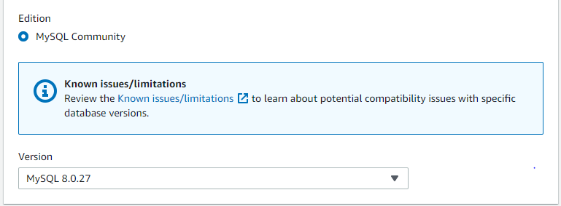

6. Here i selected production template because of to configure all setting

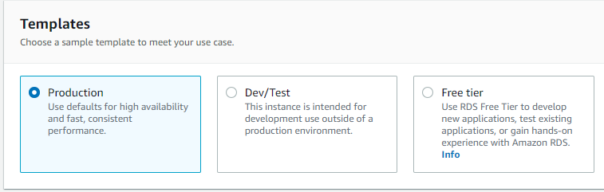

7. There is three deployment option to choose but i select single DB instance

because of its only practice no need to select multi - az db instance.

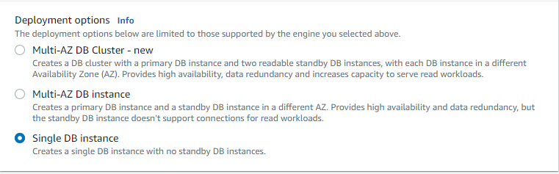

8. Its a DB instance identifier ‘database-1’

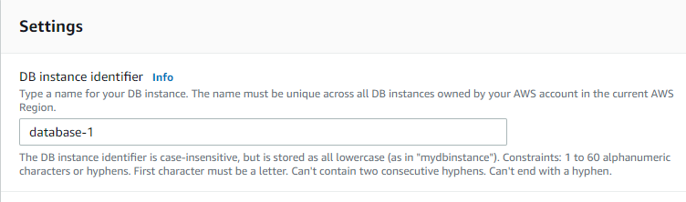

9. Here is credencial setting, i didt select auto generated password

Created as

Username - admin

Password - rishi123

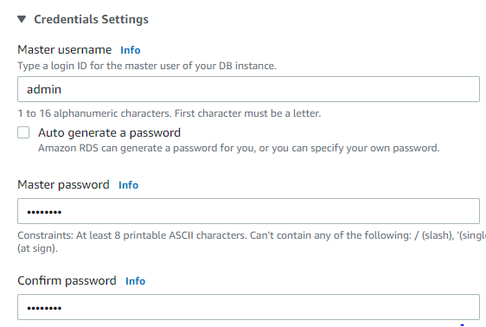

10. It is DB instance class i choose db.t3.micro because of low cost.

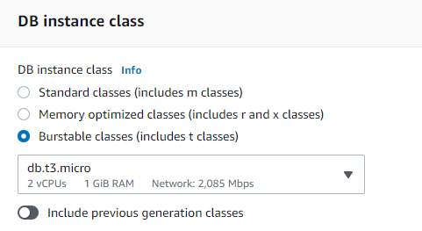

11. There is two type of storage (a) general purpose and provisioned i selected general purpose

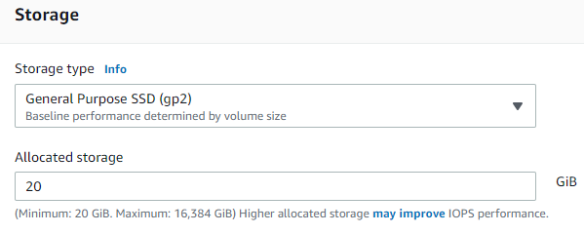

12. I don’t need to storage autoscaling.

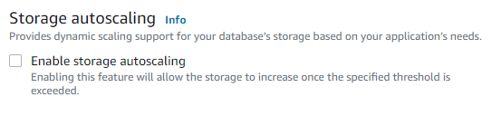

13.

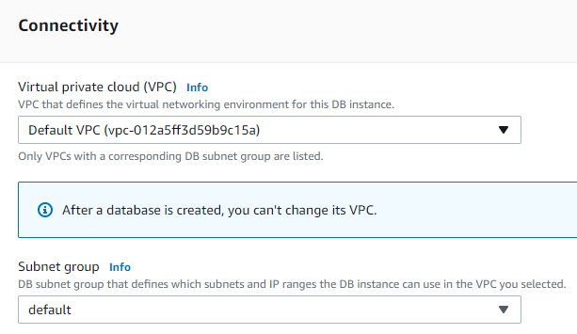

14. I need public ip so clicked on yes.

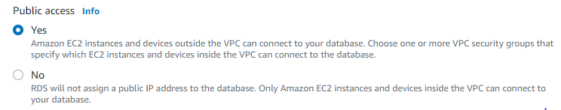

15. Here i create a new security group as RDS-sg at Az 1c

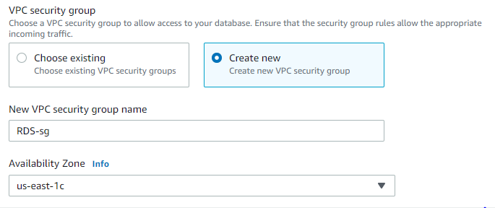

16. There is port no 3306 but after created rds have to add one more port no 22 (ssh)

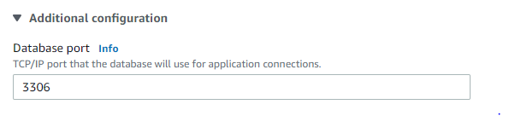

17. Database authentication i select password authentication.

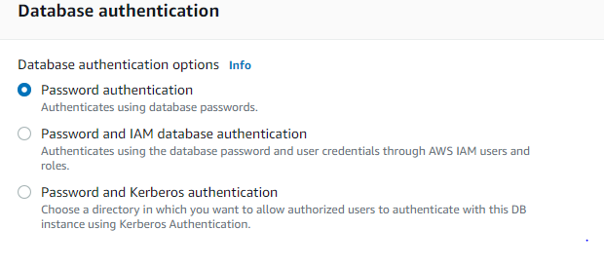

18. Database name db_1

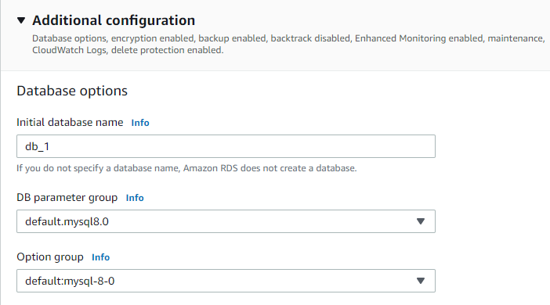

19. I don’t need autobackup encryption monitoring and log expert but in real scenario must be

consider.

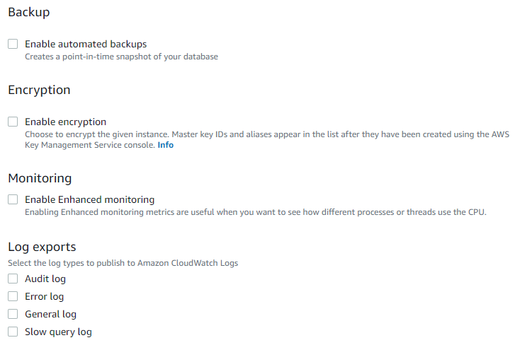

20.

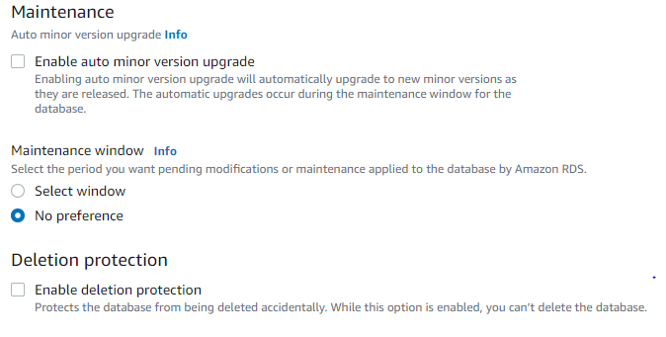

21. Here cost is DB instance and storage of ebs type of volume. Now click on create.

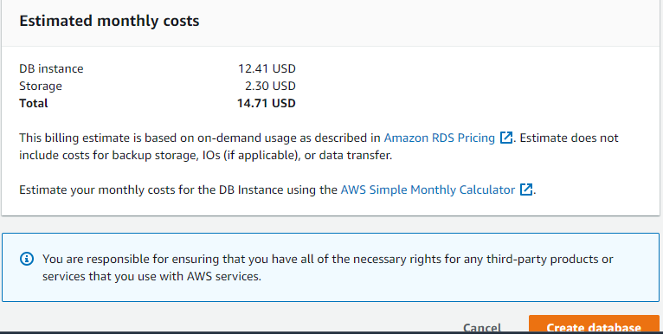

22. After created rds i add port 22(ssh) on inbound

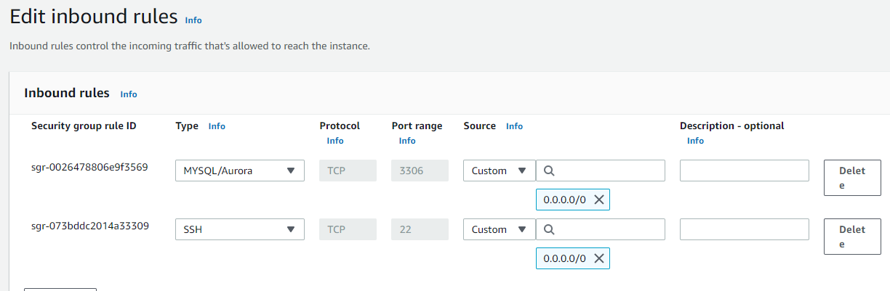

**1.1** **Now create Linux instance.**



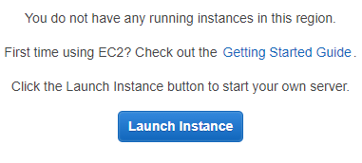

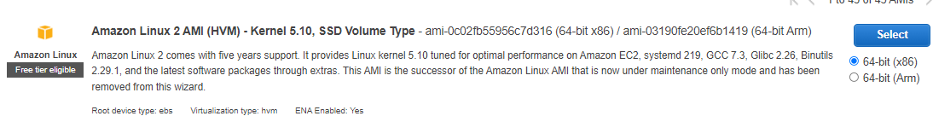

2.



3.

4. 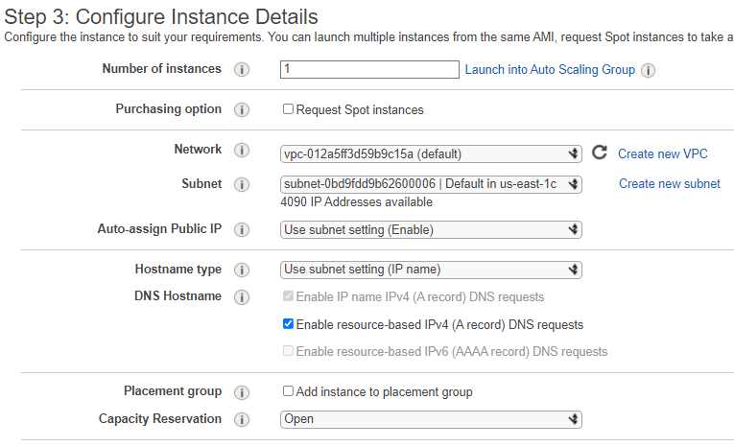

5.

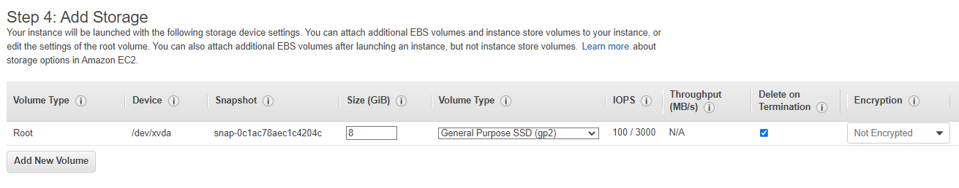

6.

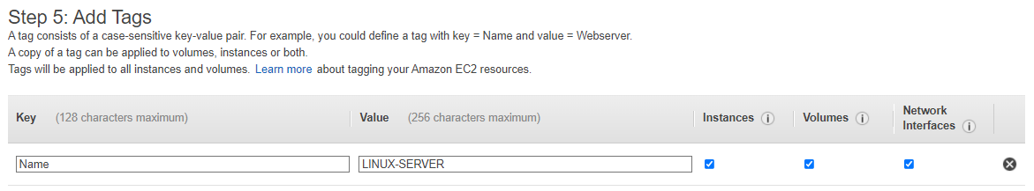

7.

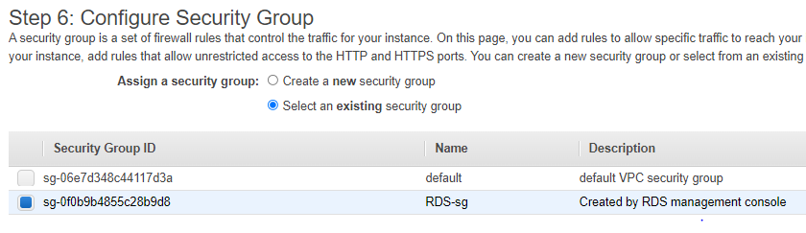

8.

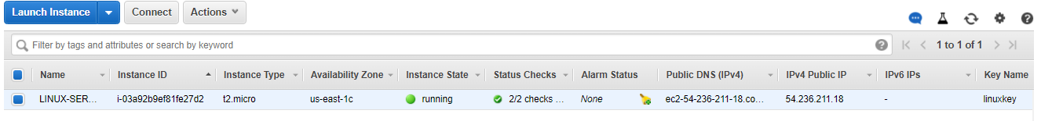

**1.2** **Now go to puttygen and putty to connect linux machine.**

1. 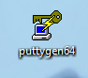
2. Load the keypair of linux machine.

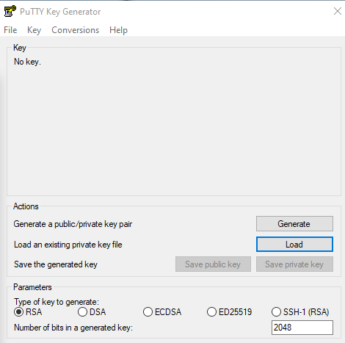



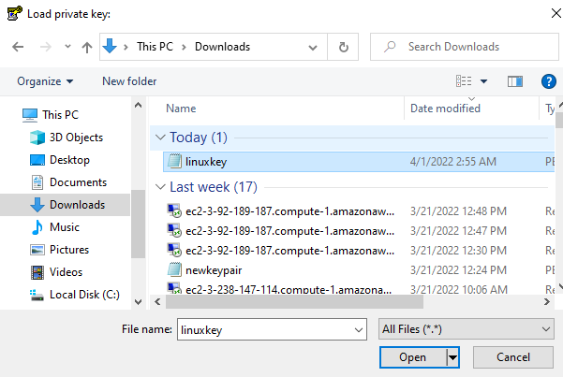



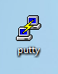



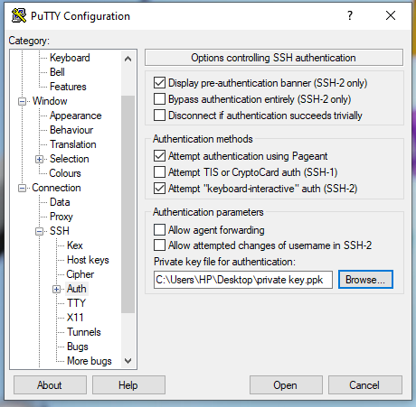

1. 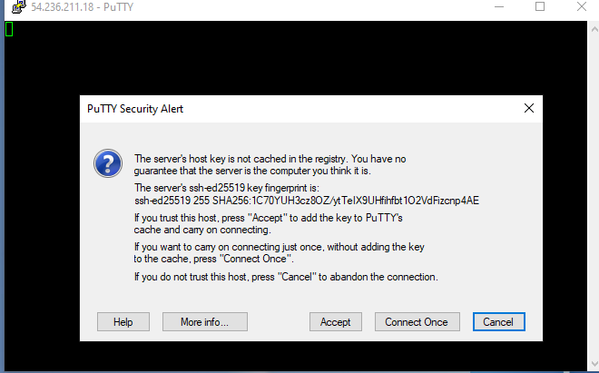
2. Cmd ec2-user

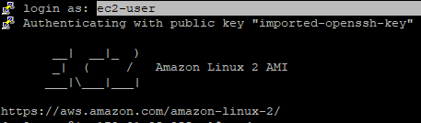

1. Cmd Sudo su -



1. Cmd to install the package ( Yum install -y mysql)

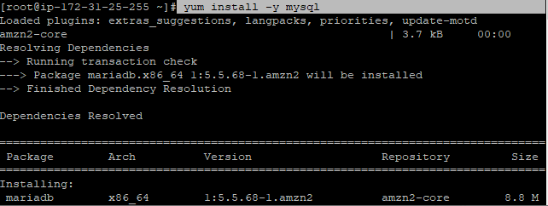

1. Mysql successfully install

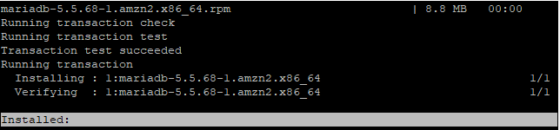

1. Mysql -h endpoint url -u admin -p dba_1



1. It successfully created as can see “MySql[db_1]”

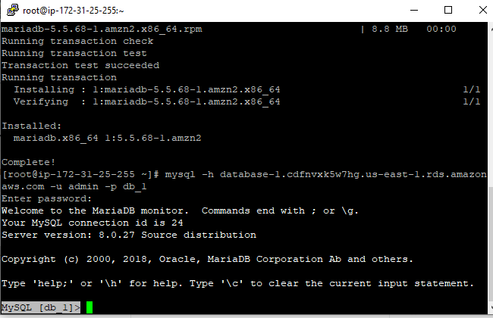

Thankyou